Please do this in sandbox.

There is a custom field in sandbox titled Invoice CTC Number.

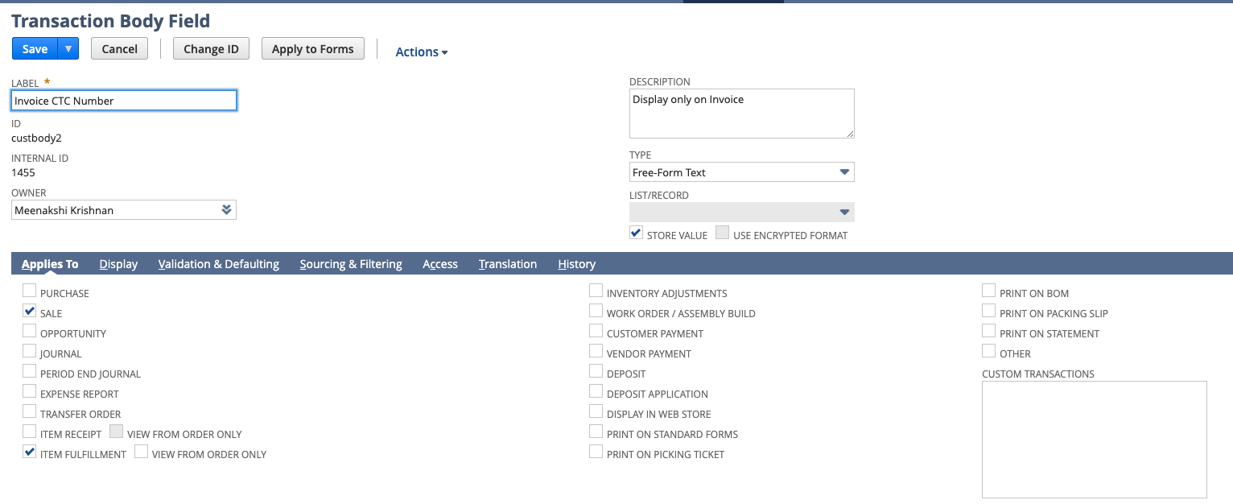

This field exists on the item fulfillment record as well as the sales order and invoice. The field gets populated on the Item Fulfillment by a 945 EDI transaction.

What we want is to have a script developed to populate the value from the item fulfillment to the associated invoice and sales order.

We need to keep the ‘store value’ box checked on the field so we can use this on reports.

The script can be scheduled because the field on the item fulfillment will be populated prior to the invoice being created, so we will want the field to be populated on the sales order and invoice.

Let me know if you have any questions.